
Reach for the Star | GCSE Mathematics 1MA1 | L104

Knowledge organiser: Non-calculator number and algebra
Objective: Apply number and algebra methods without a calculator.
Calculator condition: Calculator allowed where labelled; non-calculator reasoning remains required.
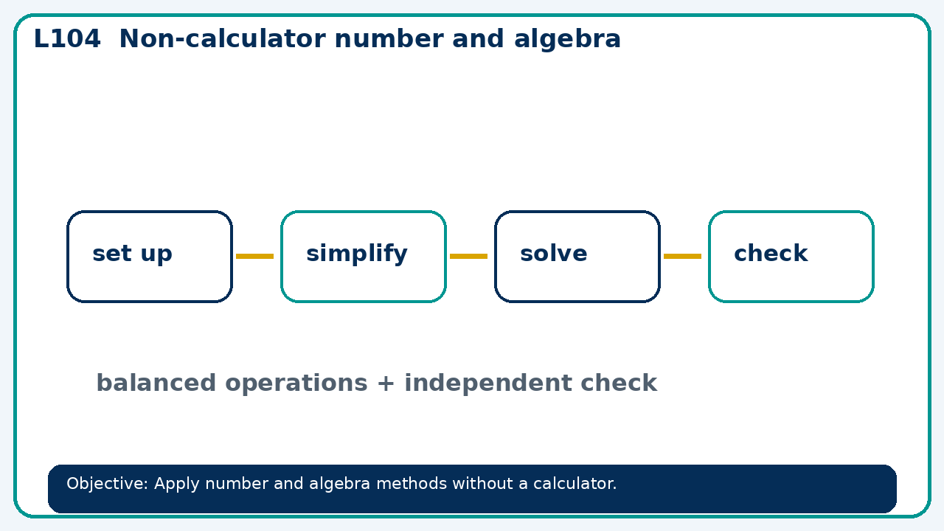

Core knowledge
- Use assessment evidence to select a worked-example/problem pair.
- Fade prompts and review a fresh independent response with the learner

Method checklist
- Identify what the question is asking.
- Choose the relevant representation or method.
- Show working clearly and label units.
- Check the answer against the original context.
- Write one sentence explaining why the answer is reasonable.

Common error to avoid
- Solve 2(3x−1)=4x+10 without a calculator and check.

