
Reach for the Star | GCSE Mathematics 1MA1 | L105

Knowledge organiser: Calculator fluency and accuracy
Objective: Use a calculator efficiently while checking magnitude, accuracy and units.
Calculator condition: Calculator allowed where labelled; non-calculator reasoning remains required.
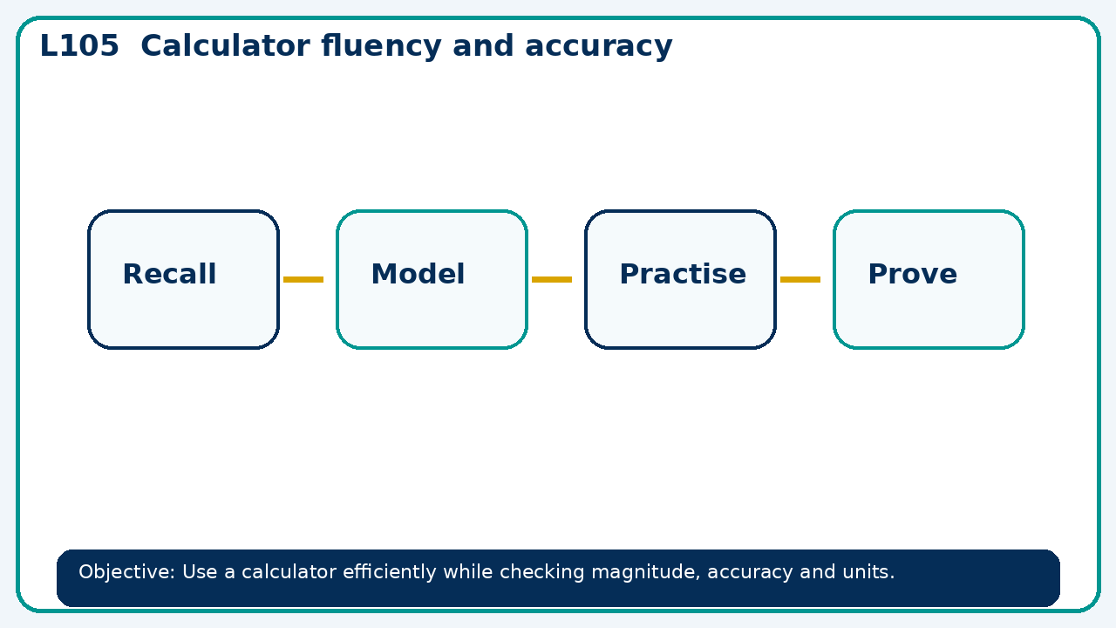

Core knowledge
- Use assessment evidence to select a worked-example/problem pair.
- Fade prompts and review a fresh independent response with the learner

Method checklist
- Identify what the question is asking.
- Choose the relevant representation or method.
- Show working clearly and label units.
- Check the answer against the original context.
- Write one sentence explaining why the answer is reasonable.

Common error to avoid
- A result is 0.00048372. Round to three significant figures and explain the first significant digit.

