
Reach for the Star | GCSE Mathematics 1MA1 | L106

Learner workbook: Reasoning and multi-step problems
Objective: Explain a multi-step solution and justify method choices.
Calculator condition: Non-calculator core; calculator optional only for checking where labelled.
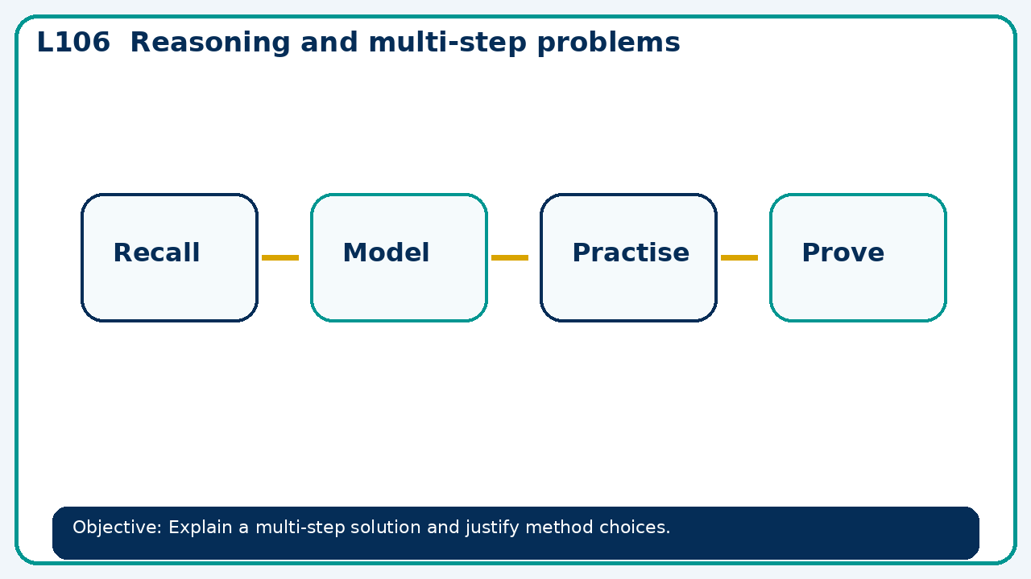

Connect & Check
- State the objective and timeline. Retrieve calculator fluency and accuracy or a prerequisite. Diagnose a common error before modelling.
- Write one starting question you want answered today.

Choose your route
Route A: Visual  Use a diagram, graph, table or annotation first. | Route B: Method  Use a worked method, formula or calculation chain first. | Route C: Explain  Start with words: what is known, what is changing, and why.

Share
- Pairs compare methods or predict a result for reasoning and multi-step problems. Ask for a reason, not only an answer.

Present
- Use assessment evidence to select a worked-example/problem pair.
- Fade prompts and review a fresh independent response with the learner

Apply: supported to independent
Recall: Retrieve the key fact or method needed for reasoning and multi-step problems.
Working: ______________________________________________________________
Check/explanation: ____________________________________________________
Core practice: A £120 item is discounted 15% then its new price increases 10%. Find final price.
Working: ______________________________________________________________
Check/explanation: ____________________________________________________
Reasoning: Explain why the order of two percentage multipliers does not affect the final number, but the story still matters.
Working: ______________________________________________________________
Check/explanation: ____________________________________________________
Exam-style: Solve an exam-style problem involving reasoning and multi-step problems. Show working, include a check and interpret your answer.
Working: ______________________________________________________________
Check/explanation: ____________________________________________________

Recall & Review
- Revisit the objective. Learners solve a fresh item without prompts, explain a check, correct one error and record the next practice.
WWW: ________________________________ EBI: ________________________________

Recall & Review: feedback and extension integration
Lesson L106: Reasoning and multi-step problems
Objective: Explain a multi-step solution and justify method choices.
Timing for a 60-minute lesson
0-7 Connect & Check; 7-14 Share; 14-25 Present/model; 25-44 Apply route choice/practice; 44-52 independent exam-style check; 52-60 Recall & Review, WWW/EBI and next step.
Recall & Review evidence
At the end of the lesson, solve a fresh question without prompts, explain one check, correct one error and record the next practice step.
What Went Well (WWW)
I used my working and assessment evidence to identify the exact mathematical step that was secure and the specific misconception that needs attention.
Even Better If (EBI)
I will correct one precise step, explain why the correction works and complete a fresh delayed question without the original scaffold.
Integrated stretch and deep challenge
Stretch: A £120 item is discounted 15% then its new price increases 10%. Find final price.
Deep challenge: Explain why the order of two percentage multipliers does not affect the final number, but the story still matters.
My next-step response

