
Reach for the Star | GCSE Mathematics 1MA1 | L108

Knowledge organiser: Personal revision plan and flexible repair
Objective: Plan spaced revision and choose manageable next steps from evidence.
Calculator condition: Non-calculator core; calculator optional only for checking where labelled.
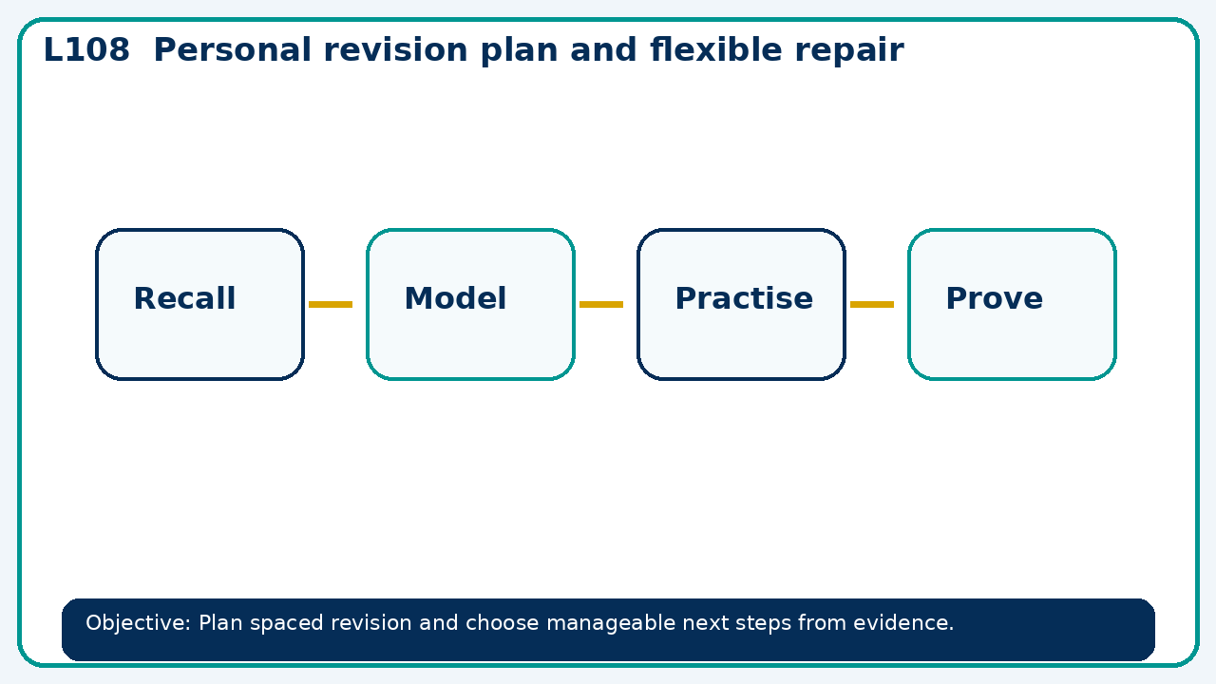

Core knowledge
- Use assessment evidence to select a worked-example/problem pair.
- Fade prompts and review a fresh independent response with the learner

Method checklist
- Identify what the question is asking.
- Choose the relevant representation or method.
- Show working clearly and label units.
- Check the answer against the original context.
- Write one sentence explaining why the answer is reasonable.

Common error to avoid
- A learner can answer only when following a model. What evidence would justify removing the scaffold?

